**Automating Infrastructure using Terraform**

1. **Install Terraform:**

Check if terraform is installed or follow below steps**:**

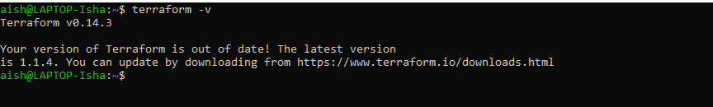

Repository config and installation of terraform:

# curl -fsSL https://apt.releases.hashicorp.com/gpg | sudo apt-key add –

# sudo apt-add-repository "deb [arch=$(dpkg --print-architecture)] https://apt.releases.hashicorp.com $(lsb_release -cs) main"

# sudo apt install terraform

Install awscli:

# sudo pip install awscli

# sudo apt-get update

1. **Create a terraform file and run it :**

Create the .tf file having the credentials and instance details. We will need to add key to this instance to be able to connect to instance through ssh and use ansible.

Also we need to enable port 22 through a security group

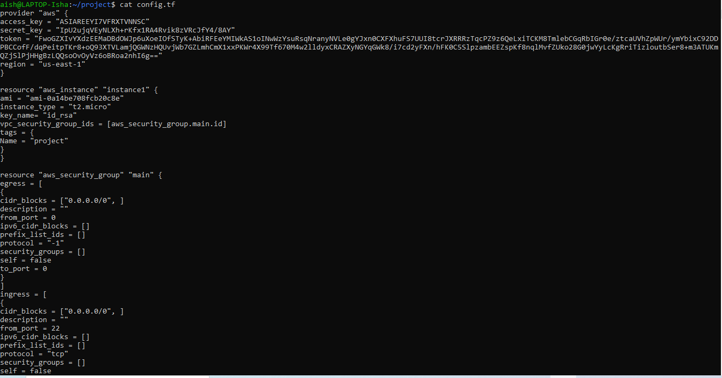

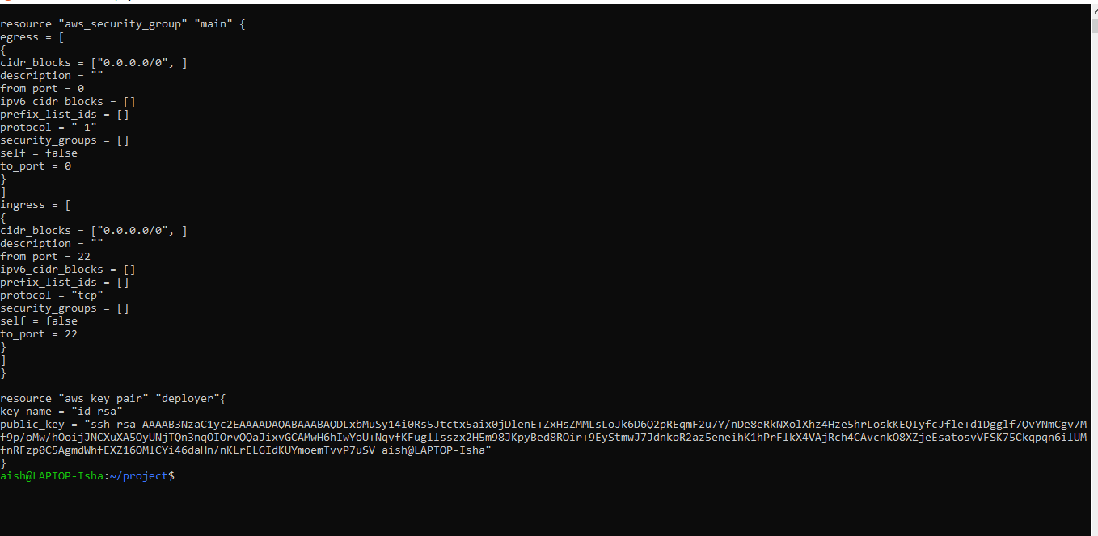

Procedure to generate ssh key:

# ssh-keygen

Note – as keys were already generated for my id , so just for ref. pasting output for root account

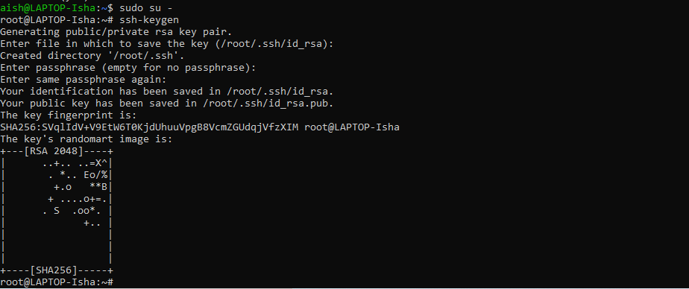

We would need to copy the public key to the terraform file we created above. After running the ssh-keygen we will see private and public key generated in our .ssh dir:

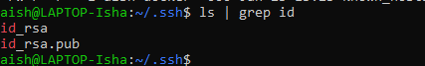



Now run the terraform using below procedure:

# terraform init

# terraform plan

# terraform apply

Here we have to add 3 things – instance , sec. group and key

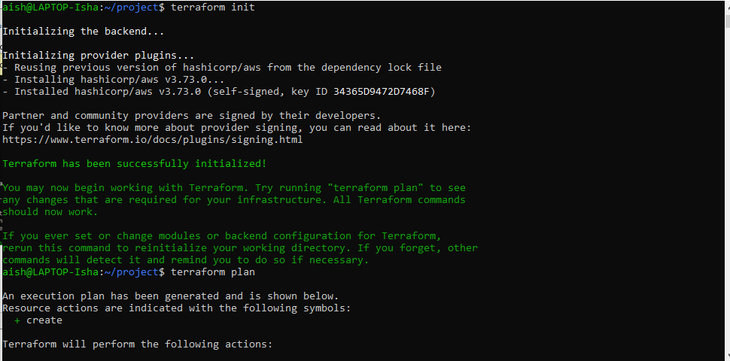

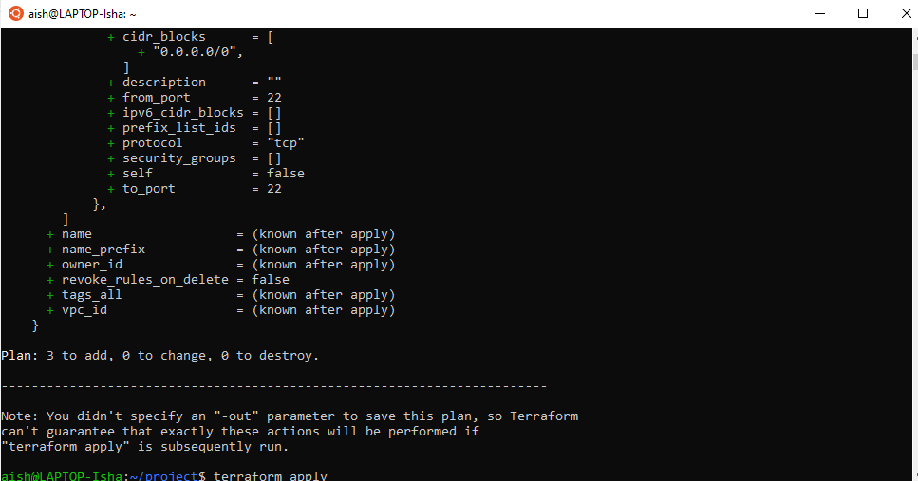

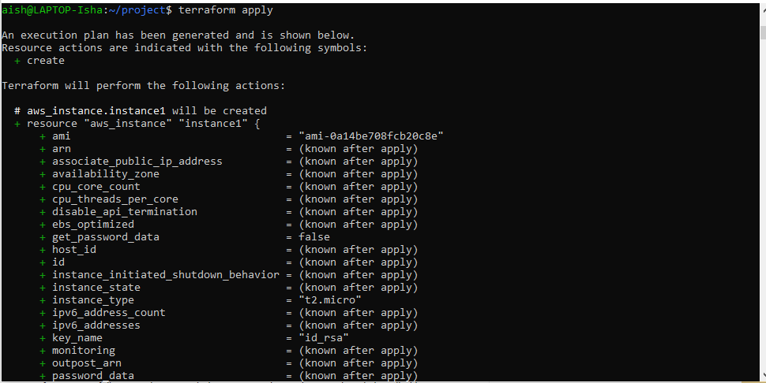

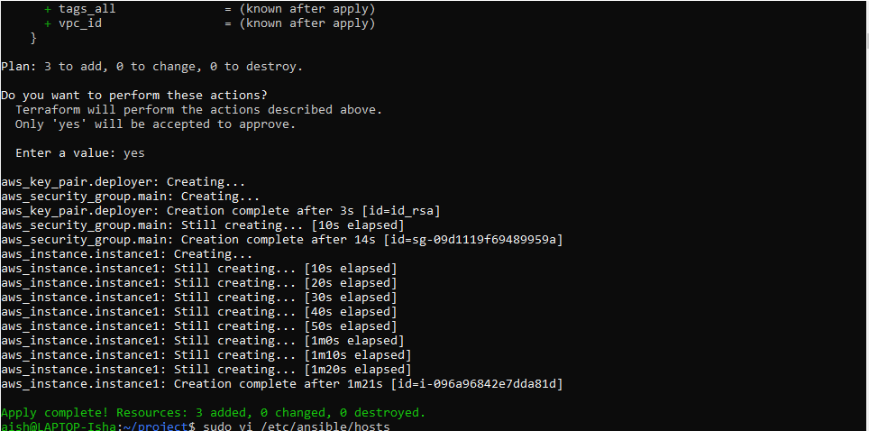

Now login to aws console to verify the instance , key-pair and security grp creation:

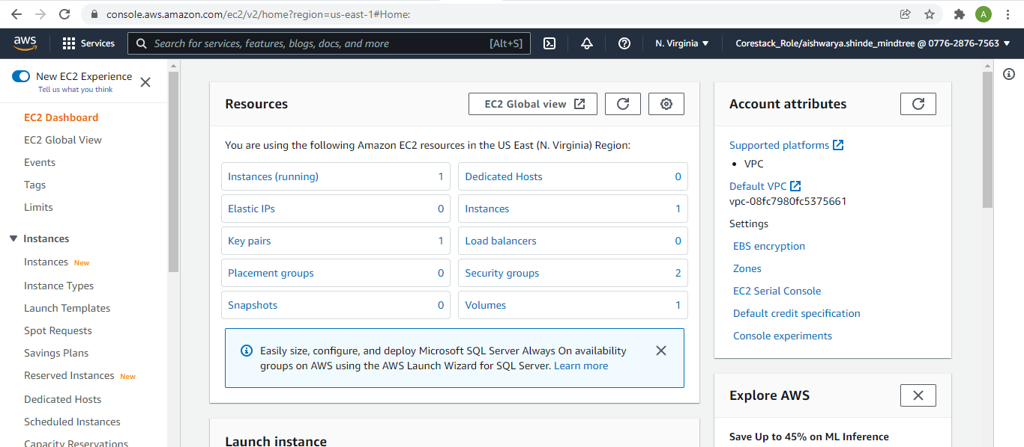

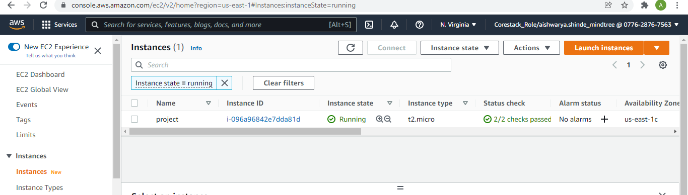

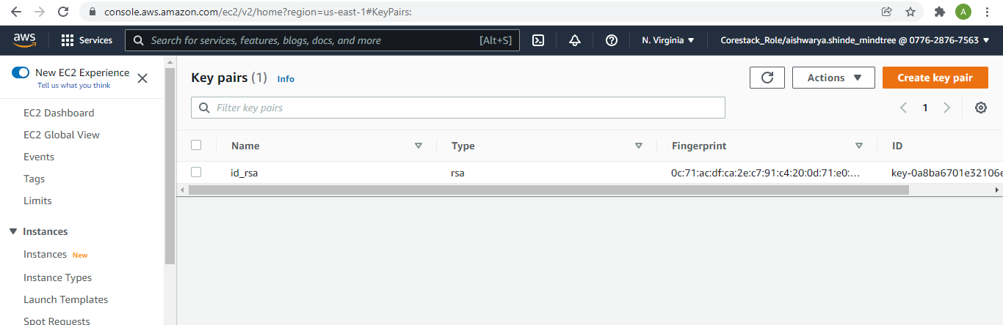

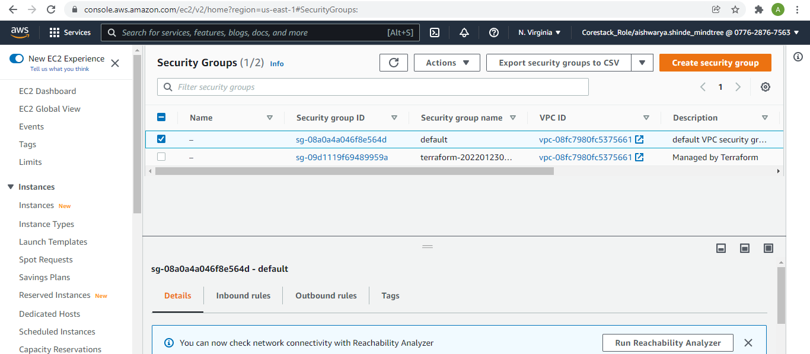

Here we can see the details of our instance and use connect tab to connect :

IP – 172.31.82.59

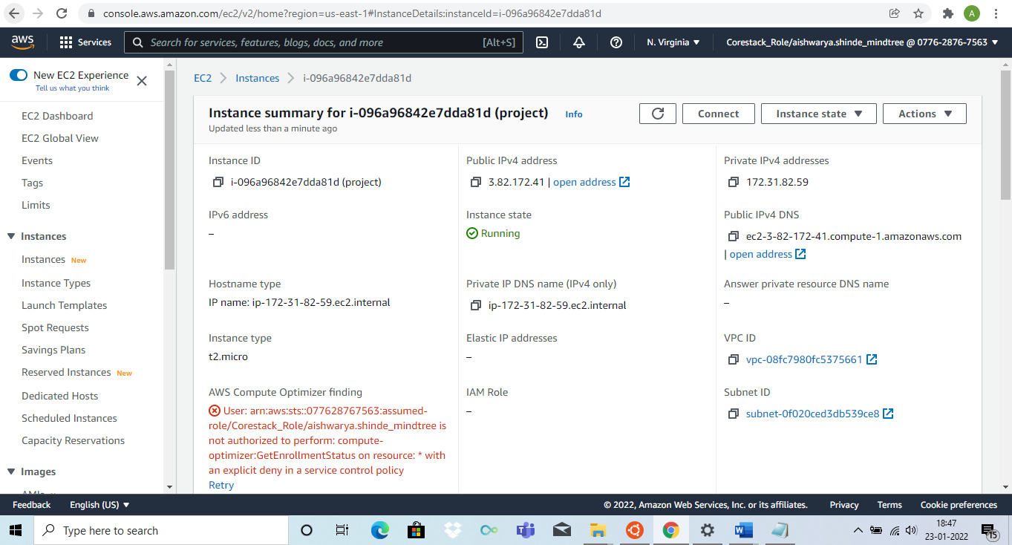

In ssh client tab we can get the commands to connect to our ec2 instance:

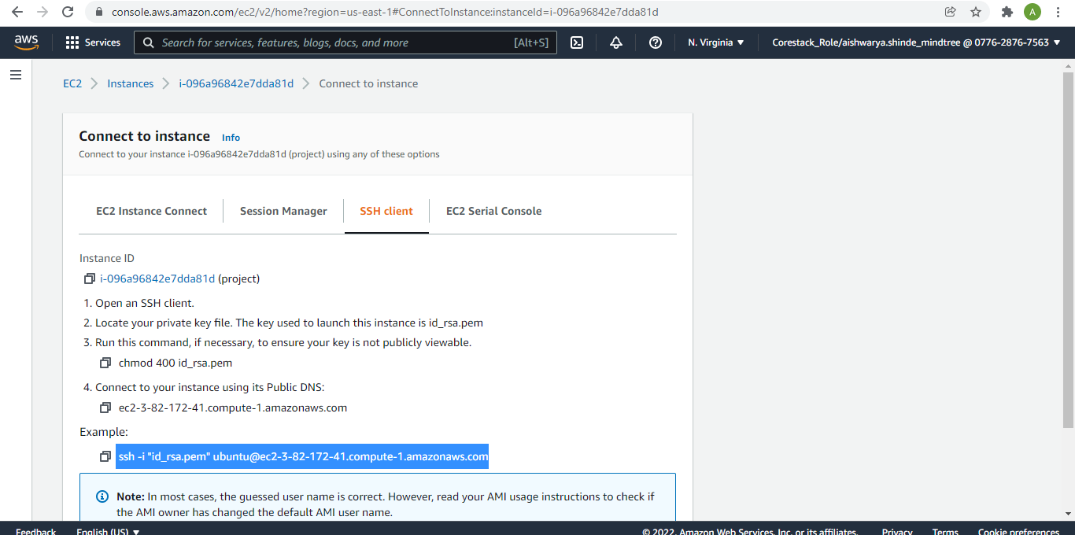

Check if you can connect to ec2:

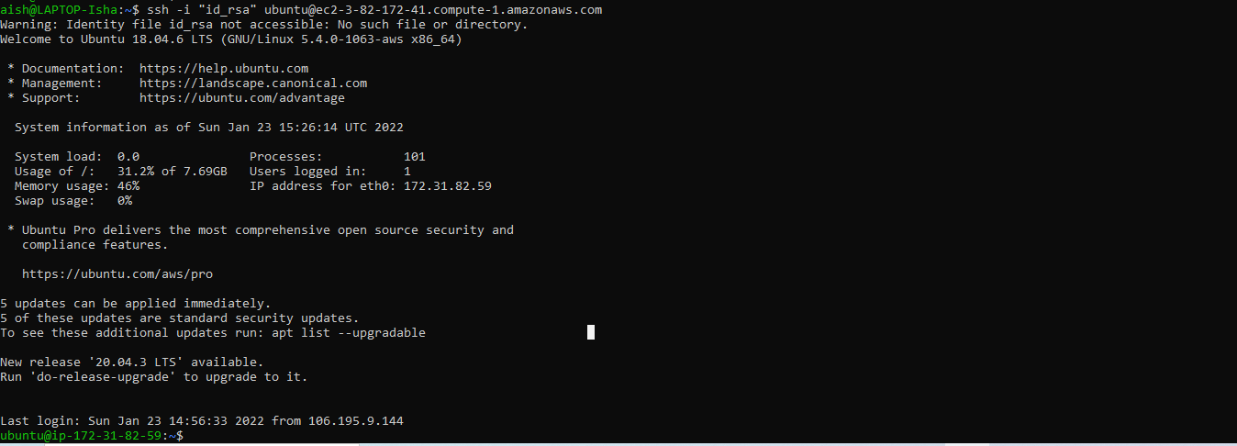

1. **Install Ansible:**

Check if ansible is installed with below command:

# ansible –version

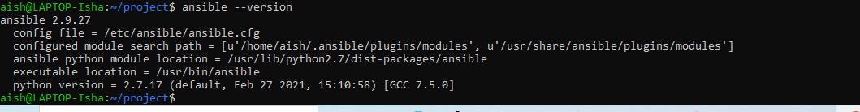

If ansible is not installed the perform the below steps to install ansible:

# sudo apt-get install -f

# sudo apt-get install software-properties-common

# sudo apt-add-repository ppa:ansible/ansible

# sudo apt-get update

# sudo apt-get install ansible

To run ansible script we need to add our ec2 instance to ansible host file as below:



Keys we already generated while creating instance through terraform.

1. **Install Java on ec2 instance using Ansible:**

Create a .yml file to install ansible :

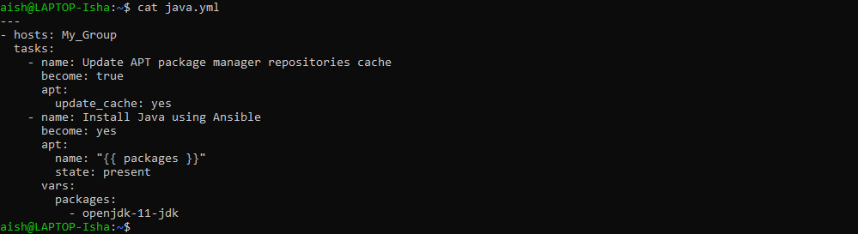

Now run this ansible script :

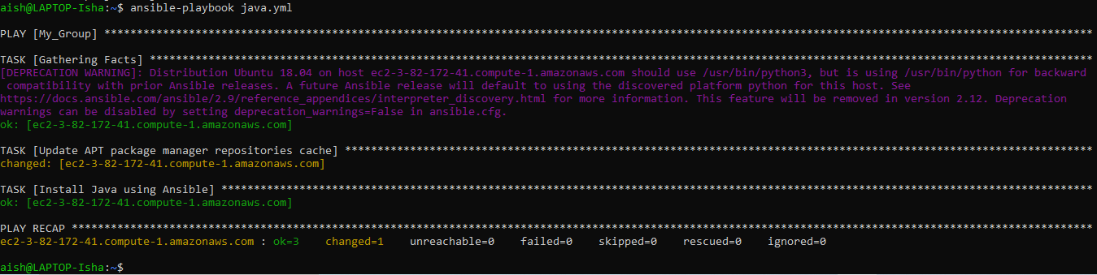

Login to our ec2 instance and check if java is installed:

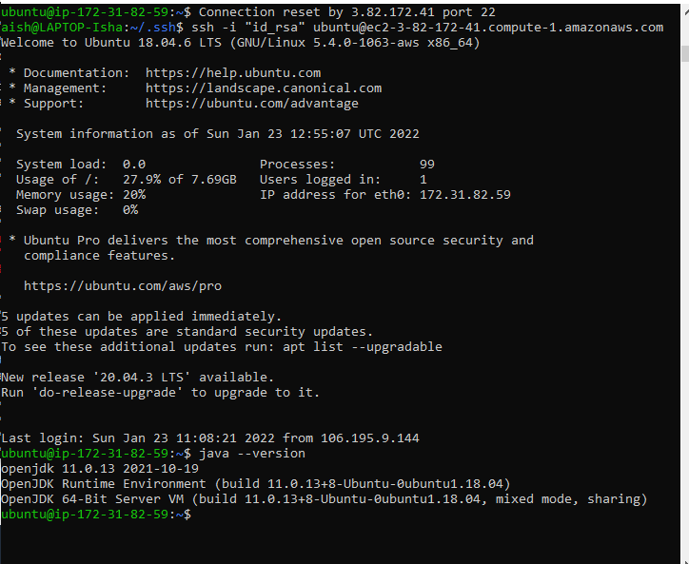

1. **Install Jenkins on ec2 instance using Ansible:**

Create the .yml file to install jenkins**:**

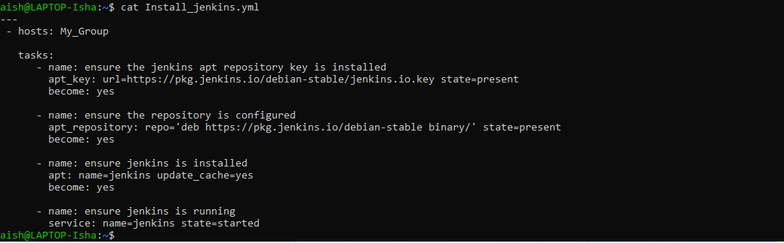

Run this script:

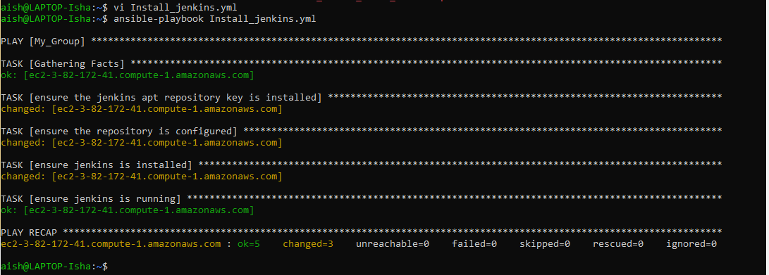

Login to our ec2 instance to verify Jenkins installation:

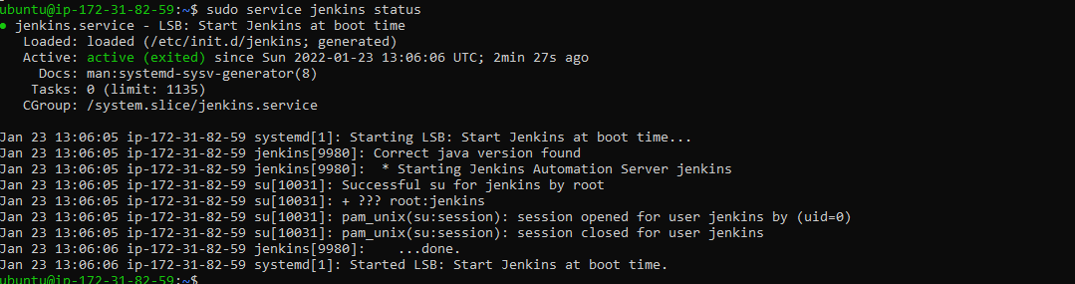

1. **Install Python on ec2 instance using Ansible:**

Create .yml file to intstall python. Here we can use python3 as it is the latest python version:

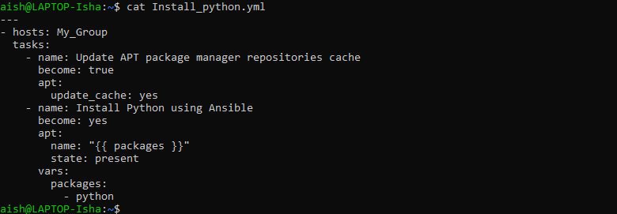

Run this playbook:

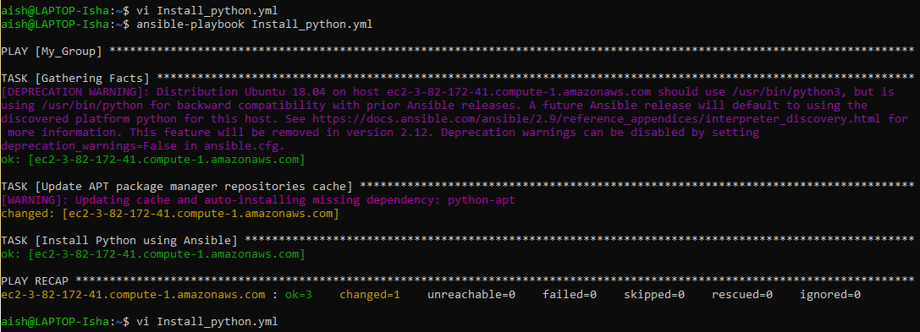

Connect to instance to verify python installation:

